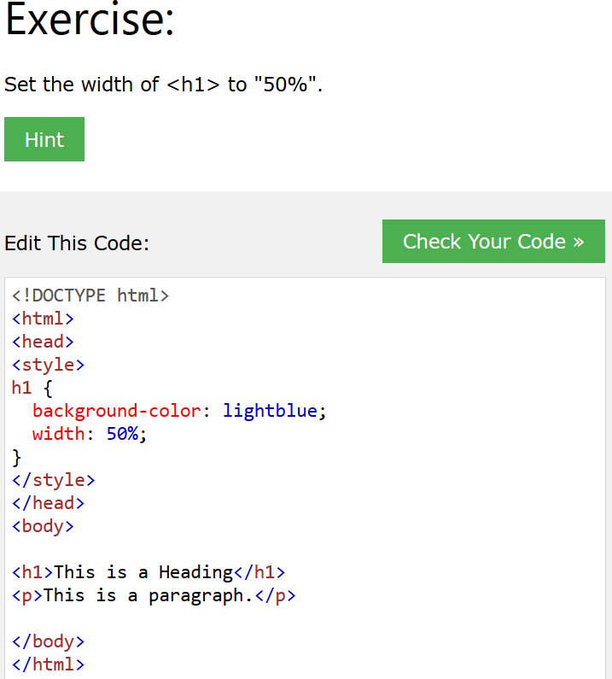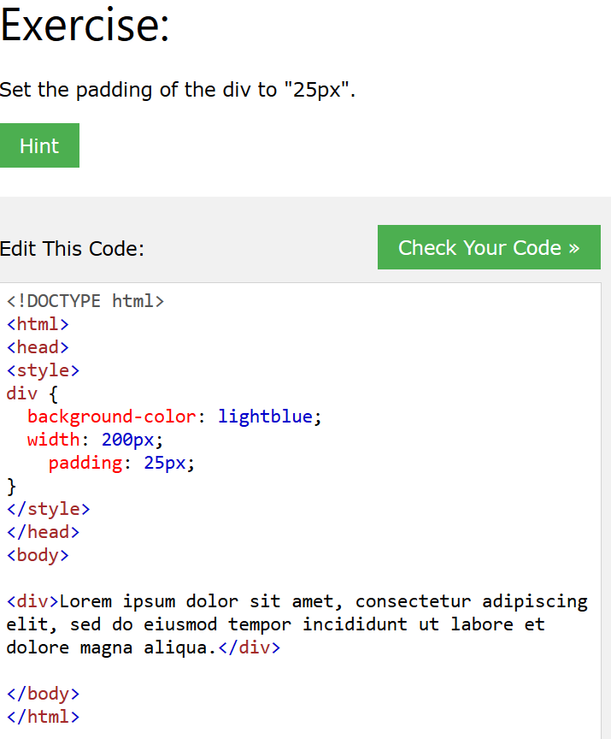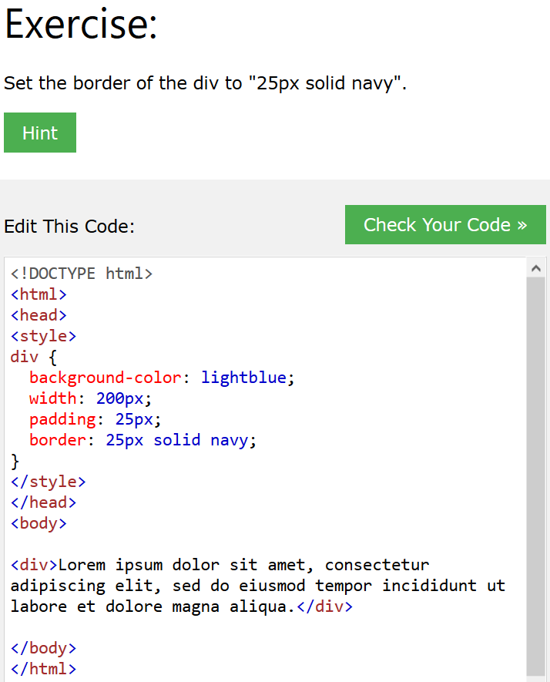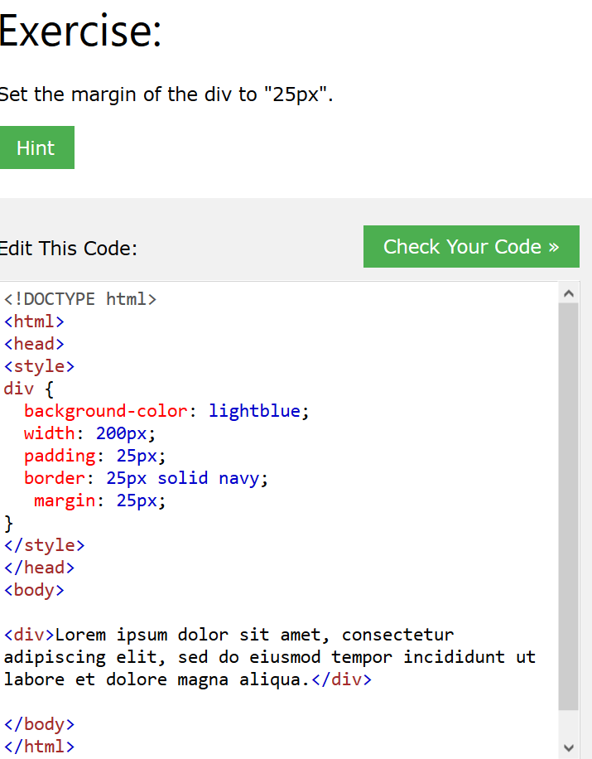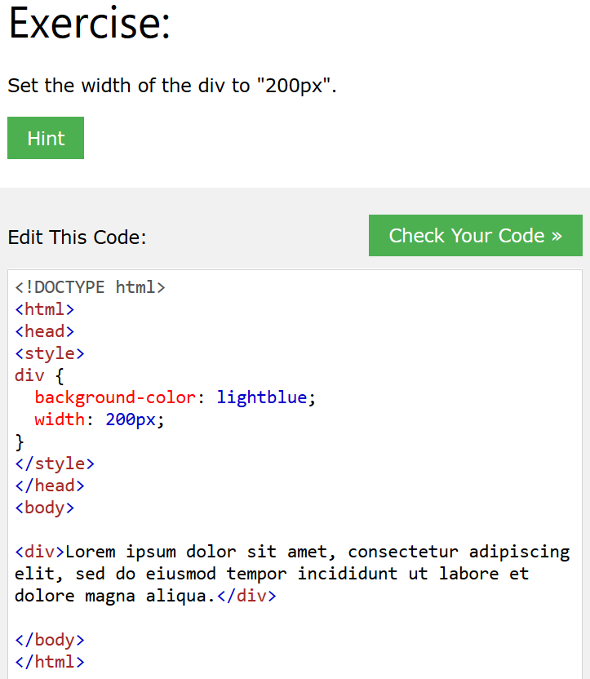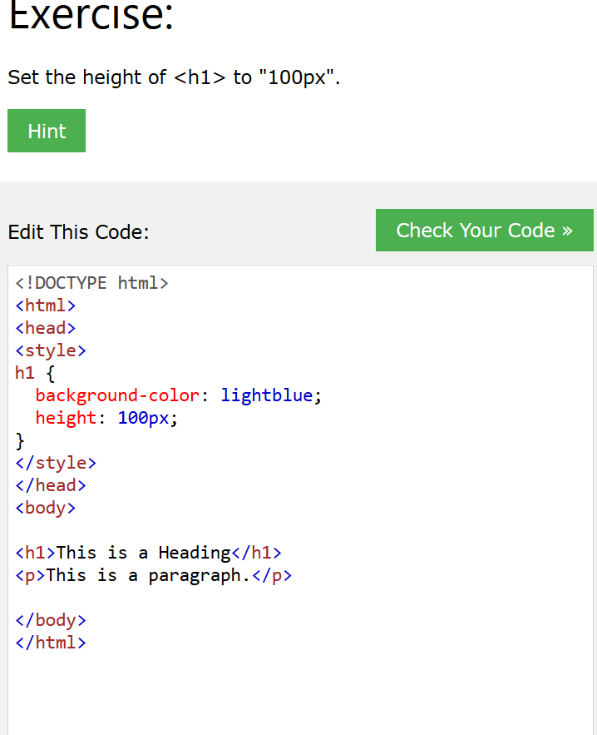

|  |
| --- |
| Change the color of all <p> elements to "red".  Hint |
| <!DOCTYPE html>  <html>  <head>  <style>  p {   color: red;  }  </style>  </head>  <body>  ​  <h1>This is a Heading</h1>  <p>This is a paragraph.</p>  <p>This is another paragraph.</p>  ​  </body>  </html> |
| Change the color of the element with id="para1", to "red".  <!DOCTYPE html>  <html>  <head><style>  #para1 {   color: red;  }  </style>  </head>  <body>  ​  <h1>This is a Heading</h1>  <p id="para1">This is a paragraph.</p>  <p>This is another paragraph.</p>  ​  </body>  </html> |

Change the color of all elements with the class "colortext", to "red".

<!DOCTYPE html>

<html>

<head>

<style>

.colortext {

color: red;

}

</style>

</head>

<body>

<h1>This is a Heading</h1>

<p>This is a paragraph.</p>

<p class="colortext">This is another paragraph.</p>

<p class="colortext">This is also a paragraph.</p>

</body>

</html>

Change the color of all <p> and <h1> elements, to "red". Group the selectors to minimize code



<!DOCTYPE html>

<html>

<head>

<style>

h1, p {

 color: red;

}

</style>

</head>

<body>

​

<h1>This is a heading</h1>

<h2>This is a smaller heading</h2>

<p>This is a paragraph.</p>

<p>This is another paragraph.</p>

​

</body>

</html>

|  |
| --- |
| Add an external style sheet with the URL: "mystyle.css".  Hint |
| <!DOCTYPE html>  <html>  <head>  <link rel="stylesheet" type="text/css" href="mystyle.css">  </head>  <body>  ​  <h1>This is a Heading</h1>  <p>This is a paragraph.</p>  <p>This is another paragraph.</p>  ​  </body>  </html> |

|  |
| --- |
| Set "background-color: linen" for the page, using an internal style sheet.  Hint |
| <!DOCTYPE html>  <html>  <head>  <style>  body {   background-color: linen;  }  </style>  </head>  <body>  ​  <h1>This is a Heading</h1>  <p>This is a paragraph.</p>  <p>This is another paragraph.</p>  ​  </body>  </html> |

|  |
| --- |
| Set "background-color: linen" for the page, using an inline style.  Hint |
| <!DOCTYPE html>  <html>  <head>  </head>  <body style="background-color: linen">  ​  <h1>This is a Heading</h1>  <p>This is a paragraph.</p>  <p>This is another paragraph.</p>  ​  </body>  </html>  ​ |

|  |
| --- |
| Remove all styles, except the external style sheet "mystyle.css".  Hint |
| <!DOCTYPE html>  <html>  <head>  <link rel="stylesheet" type="text/css" href="mystyle.css">  </head>  <body>  ​  <h1>This is a Heading</h1>  <p>This is a paragraph.</p>  <p>This is another paragraph.</p>  ​  </body>  </html> |

|  |
| --- |
| Set the background color for the page to "linen" and the background color for <h1> to "lightblue".  Hint |
| <!DOCTYPE html>  <html>  <head>  <style>  body {   background-color: linen;  }  h1 {   background-color: lightblue;  }  </style>  </head>  <body>  ​  <h1>This is a Heading</h1>  <p>This is a paragraph.</p>  <p>This is another paragraph.</p>  ​  </body>  </html> |

|  |
| --- |
| Set "paper.gif" as the background image of the page.  Hint |
| <!DOCTYPE html>  <html>  <head>  <style>  body {   background-image: url("paper.gif");  }  </style>  </head>  <body>  ​  <h1>This is a Heading</h1>  <p>This is a paragraph.</p>  <p>This is another paragraph.</p>  ​  </body>  </html> |

|  |
| --- |
| Set "gradient_bg_vertical.png" as the background image of the page, and repeat it vertically only.  Hint |
| <!DOCTYPE html>  <html>  <head>  <style>  body {   background-image: url("gradient_bg_vertical.png");   background-repeat: repeat-y;  }  </style>  </head>  <body>  ​  <h1>This is a Heading</h1>  <p>This is a paragraph.</p>  <p>This is another paragraph.</p>  ​  </body>  </html> |

|  |
| --- |
| Specify that the background image should be shown once, in the top right corner.  Hint |
| <!DOCTYPE html>  <html>  <head>  <style>  body {   background-image: url("img_tree.png");   background-repeat: no-repeat;   background-position: top right;  }  </style>  </head>  <body>  ​  <h1>This is a Heading</h1>  <p>This is a paragraph.</p>  <p>This is another paragraph.</p>  ​  </body>  </html>  ​ |

|  |
| --- |
| Use the shorthand background property to set background image to "img_tree.png", show it once, in the top right corner.  Hint |
| <!DOCTYPE html>  <html>  <head>  <style>  body {   background: url("img_tree.png") no-repeat top right;  }  </style>  </head>  <body>  ​  <h1>This is a Heading</h1>  <p>This is a paragraph.</p>  <p>This is another paragraph.</p>  ​  </body>  </html> |

|  |
| --- |
| Set a "4px", "dotted" border for <p>.  Hint |
| <!DOCTYPE html>  <html>  <head>  <style>  p {   border-style: dotted;   border-width: 4px;  }  </style>  </head>  <body>  ​  <h1>This is a Heading</h1>  <p>This is a paragraph.</p>  ​  </body>  </html> |

|  |
| --- |
| Set the border color for <p> to "red".  Hint |
| <!DOCTYPE html>  <html>  <head>  <style>  p {   border-style: dotted;   border-width: 4px;   border-color: red;  }  </style>  </head>  <body>  ​  <h1>This is a Heading</h1>  <p>This is a paragraph.</p>  ​  </body>  </html> |

|  |
| --- |
| Change the 3 border properties, so that they only show the border on the top side.  Hint |
| <!DOCTYPE html>  <html>  <head>  <style>  p {   border-top-style: dotted;   border-top-width: 4px;   border-top-color: red;  }  </style>  </head>  <body>  ​  <h1>This is a Heading</h1>  <p>This is a paragraph.</p>  ​  </body>  </html> |

|  |
| --- |
| With the border property: Set the border for p to "10px", "solid" and "green".  Hint |
| <!DOCTYPE html>  <html>  <head>  <style>  p {   border: 10px solid green;  }  </style>  </head>  <body>  ​  <h1>This is a Heading</h1>  <p>This is a paragraph.</p>  ​  </body>  </html>  ​ |

|  |
| --- |
| Set the left margin of <h1> to "20px".  Hint |
| <!DOCTYPE html>  <html>  <head>  <style>  h1 {   background-color: lightblue;   margin-left: 20px;  }  </style>  </head>  <body>  ​  <h1>This is a Heading</h1>  <p>This is a paragraph.</p>  ​  </body>  </html> |

|  |
| --- |
| Set all margins for <h1> to "25px".  Hint |
| <!DOCTYPE html>  <html>  <head>  <style>  h1 {   background-color: lightblue;   margin: 25px;  }  </style>  </head>  <body>  ​  <h1>This is a Heading</h1>  <p>This is a paragraph.</p>  ​  </body>  </html> |

|  |
| --- |
| Use the margin property to set the top and bottom margins for <h1> to "50px", and left and right margins to "25px".  Hint |
| <!DOCTYPE html>  <html>  <head>  <style>  h1 {   background-color: lightblue;   margin: 50px 25px;  }  </style>  </head>  <body>  ​  <h1>This is a Heading</h1>  <p>This is a paragraph.</p>  ​  </body>  </html> |

|  |
| --- |
| Use the margin property to center align the <h1> element.  Hint |
| <!DOCTYPE html>  <html>  <head>  <style>  h1 {   background-color: lightblue;   width: 300px;   margin: auto;  }  </style>  </head>  <body>  ​  <h1>This is a Heading</h1>  <p>This is a paragraph.</p>  ​  </body>  </html> |

